Gifts and Hospitality
Policy

Approval Level: | Governing Body
Date Agreed: | Spring Term 2022
Next Review: | SEPTEMBER 2024

Contents

1. Background 4
2. Definition 4
3. Dealing with Gifts and Hospitality 4
4. Giving Gifts and Hospitality 6
5. Why REAch2 needs this Policy 7
6. Who is affected by this Policy 7
7. The Effect of Non Compliance 7
8. Review and Revision 7

Appendix 1 – Declaration of Hospitality and Gifts Form 8

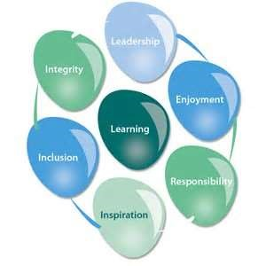
At REAch2, our actions and our intentions as school leaders are guided by our Touchstones:

Integrity We recognise that we lead by example and if we want children to grow up to behave appropriately and with integrity then we must model this behaviour.

Responsibility We act judiciously with sensitivity and care. We don’t make
 | excuses, but mindfully answer for actions and continually seek to make improvements.
Inclusion | We acknowledge and celebrate that all people are different and can play a role in the REAch2 family whatever their background or learning style.
Enjoyment | Providing learning that is relevant, motivating and engaging releases a child’s curiosity and fun, so that a task can be tackled and their goals achieved.
Inspiration | Inspiration breathes life into our schools. Introducing children to influential experiences of people and place, motivates them to live their lives to the full.
Learning | Children and adults will flourish in their learning and through learning discover a future that is worth pursuing.
Leadership | REAch2 aspires for high quality leadership by seeking out talent, developing potential and spotting the possible in people as well as the actual.

Background

In accordance with the Academies Financial Handbook 2017 (section 3.5), this policy document outlines the responsibility of The Trust, its Academies and employees, in relation to the acceptance of the following from persons or organisations external to the REAch2, including its supply chain:

- Gifts
- Hospitality
- Awards
- Any other benefit that might be seen to compromise personal judgment or integrity.

It is the responsibility of the CEO of REAch2 (the Trust) and the Head Teacher’s from each Academy to ensure that its staff members have read and understood this policy document.

The Trust and each Academy will hold a Gifts and Hospitality Register. All gifts/hospitality over the value of £30 must be recorded in the Gifts and Hospitality Register. A form should be completed in all cases where the value exceeds £30 (see Appendix A for the template).

Definition

A Gift is any item or service, award, prize or any other benefit which is received free of charge; or personally offered at a discounted rate or on terms not available to the general public or which might be seen to compromise the personal judgment or integrity of the recipient.

Hospitality is the offer of food, drink, accommodation or entertainment or the opportunity to attend any cultural or sporting event not available to the general public.

Dealing with Gifts and Hospitality

The Trust expects staff, trustees and Governors to exercise the utmost discretion in giving and accepting gifts and hospitality when on Trust or Academy business. Particular care should be taken about a gift from a person or organization that has, or is hoping to have, a contract with our organization. In any case of doubt advice should be sought from their Line Manager or Trust Directors.

Staff, trustees and Governors must not make use of their official position to further their private interests or those of others.

Staff, trustees and Governors must not accept gifts, hospitality or benefits of any kind from a third party where it might be perceived that their personal integrity is being compromised, or that the Trust/Academy might be placed under an obligation.

Gifts of low intrinsic value such as promotional calendars or diaries, small tokens of gratitude, can be accepted. If there is any doubt as to whether the acceptance of such an item is appropriate, individuals should decline the gift or refer the matter to their Line Manager or Trust Directors.

It is common for appreciative parents and pupils to register their thanks for the work of staff in the form of a small personal gift. If these are valued at less than £30 these are perfectly acceptable without reference to senior members of staff. These will not need to be recorded in the register. Where gifts valued over £30 are accepted, these should be recorded in the register.

Where a more valuable gift, benefit or service is offered which is to the good of the Academy, rather than an individual, it must be referred to the Head Teacher, or if in the case of the Head Teacher, to the Regional Director for approval within their discretion; if acceptable, then these terms must be recorded in the register.

Hospitality such as working lunches, coffees etc are perfectly acceptable where it is appropriate to offer or receive these in support of good relationships with visiting staff or business colleagues. Modest hospitality, provided it is reasonable in the circumstances, should be similar to the scale of hospitality which the Trust as an employer would be likely to offer. These would not be added to the register. Hospitality received above this level should be recorded in the register.

If a member of staff, trustee or Governor is offered a gift or hospitality whilst involved in the procurement of goods and services, tenders for work or when liaising with anyone conducting business with the academy (other than light refreshments) it is their responsibility to discuss this with their Line Manager immediately.

If not accepting a gift would be regarded as causing offence (such as a sudden and unexpected gift or one where refusal could cause cultural offence) the item should be accepted. The matter should then be brought to the attention of the Head Teacher as soon as possible, who may decide to return the gift, or may donate it to the Academy raffle/fair or a charitable cause.

Examples of gifts or hospitality that should not be accepted are cash or monetary gifts; gifts or hospitality offers to a member of your family; gifts or hospitality from a potential supplier or tenderer in the immediate period before tenders are invited or during the tender process; staff, trustee or Governor attendance at sporting and cultural events at the invitation of suppliers, potential suppliers or consultants. (Where it is considered that there is a benefit to the Trust or one of its academies in a member of staff, trustee or Governor attending a sponsored event, the attendance must be formally approved and registered by the Head Teacher).

Where a gift is received on behalf of the Academy, the gift remains the property of the Academy. The gift may be required for departmental display or it may, with the Head teacher’s approval, remain in the care of the recipient. Unless otherwise agreed, the gift should be returned to the department on or before the recipient’s last working day.

Gifts are sometimes offered by suppliers with the purchase of items. All such special offer gifts are the property of the Academy and must be used accordingly.

Giving Gifts and Hospitality

The Trust and its academies will not normally give gifts to other individuals or organisations. If gifts are given, staff must ensure that the decision is fully documented in the Gift and Hospitality Register and has regard to the propriety and regularity of the use of public funds. This does not apply to the award of gifts, prizes etc. related to the achievement of pupils e.g. attainment or merit awards.

Where hospitality is provided by the Trust or its academies this should be approved in advance by the Head Teacher. In approving hospitality, the Head Teacher should ensure it is not in breach of the UK Bribery Act 2010 and also that the costs are appropriate for a publically funded organisation.

Hospitality such as working lunches, coffees etc. and modest hospitality in the form of meals are perfectly acceptable where it is appropriate to offer or receive these in support of good relationships with visiting staff or business colleagues (but not for their family or friends). These would not be added to the register. Hospitality provided above this level should be recorded in the register.

The Trust and its Academies must fully document the decision for acceptance of the receipt of Gifts, Hospitality Awards and any other benefit that may be deemed to compromise personal judgement always ensuring that there is propriety and regularity in the use of public funds.

Why REAch2 needs this Policy

To protect the reputation of REAch2), its employees and agents from accusations of bias, partiality or favouritism.

To ensure compliance with the law including the Bribery Act 2010 and the Charities Act 1993.

Who is affected by this Policy

Trustees, staff, volunteers, supply chain partners and any other agent or supplier working for or on behalf of the REAch2.

The Effect of Non Compliance

For REAch2

Failure to comply with this Policy may result in the Trust breaching Charity Commission regulation and the Law and may also expose the Trust to unnecessary commercial or reputational risk.

For the Individual

This policy forms part of the terms and conditions of trusteeship, employment or any other contractual arrangement with the Trust. Failure to comply with this Policy and/or its associated procedures may result in disciplinary action including dismissal. Where appropriate, the Trust may also bring criminal charges and may seek to claim damages through civil proceedings.

Review and Revision

This Policy will be reviewed every three years by the Trust Board.

Independent quality and compliance reviews will be undertaken by the Trust’s internal and external auditors and, where necessary, this Policy will be updated or amended to incorporate feedback and/or operational changes.

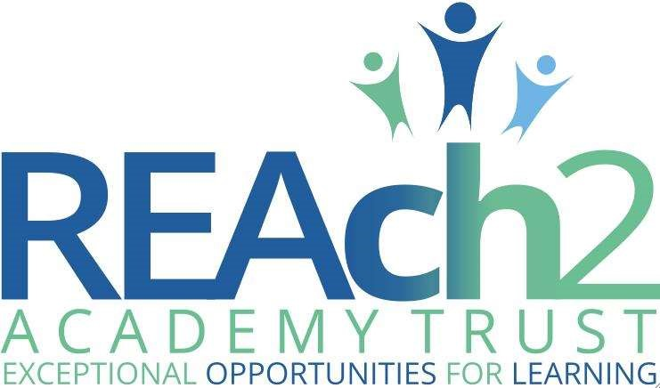
DECLARATION OF HOSPITALITY AND GIFTS FORM

Receiving benefits, gifts, rewards or hospitality in return for providing services (even if these services are part of a usual role) can be perceived as an inducement to show favour to a person or organisation in his or her official capacity. Staff and Governors are advised to decline such offers, but it is acknowledged that there may be occasions when this is not feasible. All staff and Governors should conduct themselves with integrity, impartiality and honesty at all times and should maintain high standards of propriety and professionalism.

If you have received a gift or hospitality, please complete this form and return to the School Office.

Details of the person receiving the Gift or Hospitality

Full Name
Job Title
Date of Declaration
Signature

Description of Gift or Hospitality

Description
Estimated / Actual Value
Purpose of the Offer
Person / Organisation providing the Gift or Hospitality
Relationship (or future relationship) to the person / organisation offering the gift or hospitality
Gift / Hospitality Accepted | Yes / No
Any Other Comments

Approved By

Full Name
Job Title
Date of Declaration
Signature

Entered on register | Yes / No | Register Entry Number

