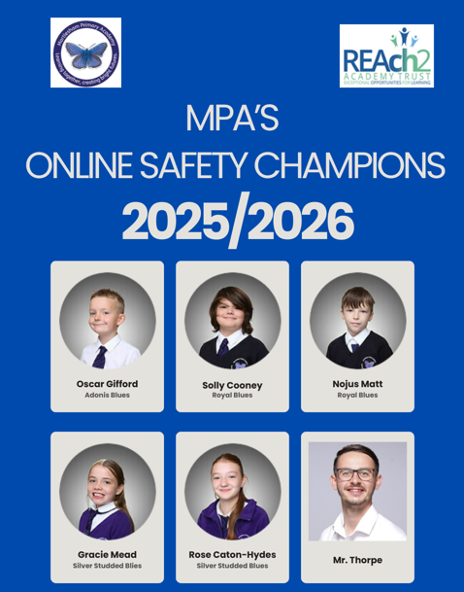

E-Safety Cafés
Each half term, our E-Safety Champions work alongside Mr Thorpe to host E-Safety Cafés. These sessions give pupils across the school the opportunity to develop their understanding of staying safe online, as well as a safe space to share any worries or experiences they may have encountered in the digital world.
The cafés are always well attended and provide a valuable opportunity for our E-Safety Champions to share practical advice and positive online habits with the wider school community.
We aim to schedule the cafés just before or shortly after school holidays, as this is typically a time when children are spending increased amounts of time using digital devices.
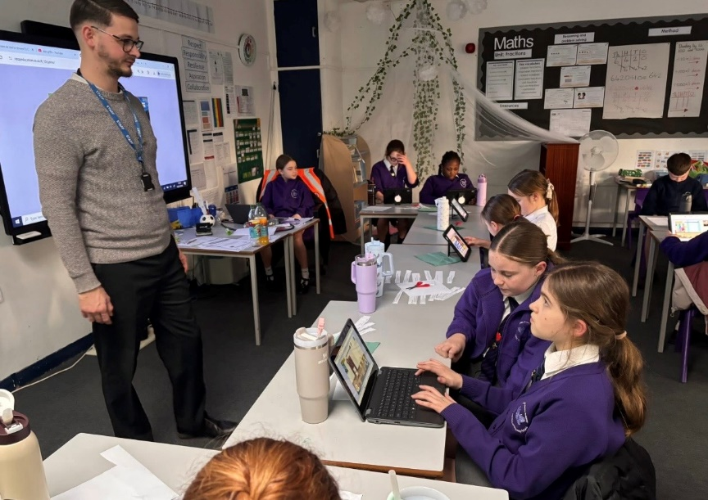

Safer Internet Day 2026
Safer Internet Day 2026 will take place on the 10th of February 2026, with celebrations and learning based around the theme ‘Smart tech, safe choices – Exploring the safe and responsible use of AI’.

Everyone’s talking about AI, and with many children and young people hearing about and using AI online, it’s important they have the skills and confidence to make safe choices when they are using smart technology.
This Safer Internet Day we are exploring the impact of AI on all of our lives, looking at how AI can be used for good, and giving advice and guidance that empowers people to use AI safely and responsibly.

Please visit this page again soon to find out more about what we got up to!

Here is a picture of our E-Safety Champions from 2024/2025 helping lead the Safer Internet Day assembly!
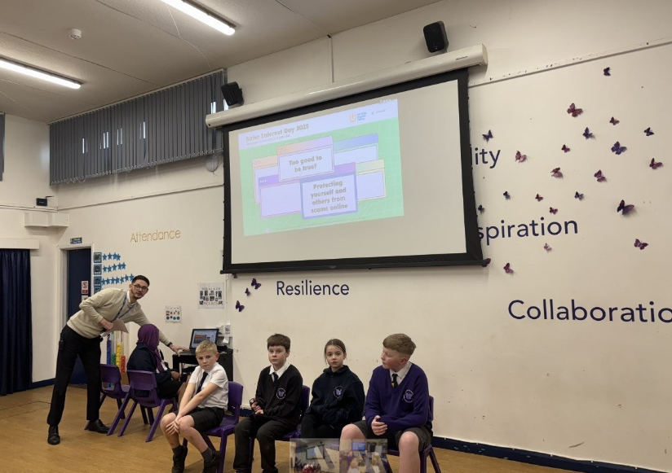

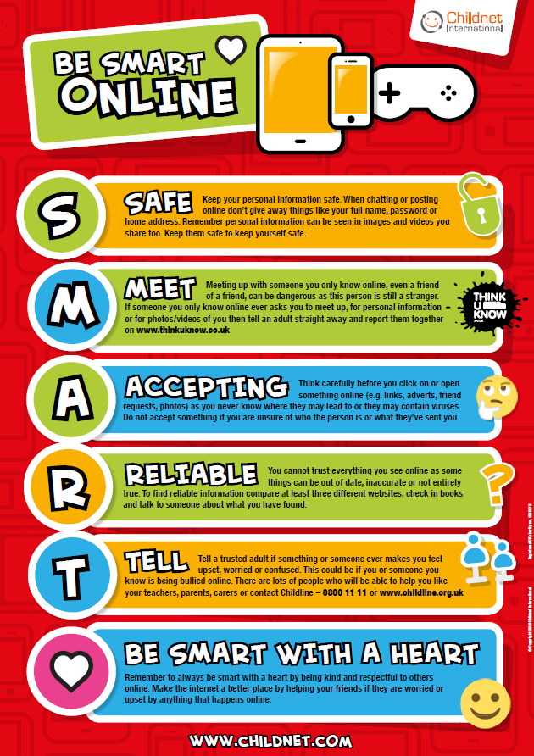

Useful Websites for parents:
https://www.childnet.com/

https://www.internetmatters.org/schools-esafety/primary/

https://www.bbc.co.uk/teach/topics/cp440njz78zt

https://www.nspcc.org.uk/keeping-children-safe/online-safety/

https://www.ceopeducation.co.uk/

An Online Safety game for children:
https://www.ceopeducation.co.uk/8_10/game/


